WMUG Saturday

Image Builder Workshop Guide

# WMUG Saturday - Image Builder Workshop Guide

## Overview

This workshop guide is intended to walk you through the (automated) deployment of a Windows 2016 server running MDT, WSUS and several other packages. We will be using PowerShell and Azure Resource Manager templates (ARM) to deploy and configure the server.

***Disclaimer: Do not run this lab on an Azure subscription that already holds Azure resources. Use the provided Azure Pass subscription. We can’t be held responsible for any damage in your (production) own subscription when the steps in this lab are performed there.***

## What you will build

* A stand alone Windows 2016 Server in Azure
* Using a public IP address and RDP access
* Additional feature setup for:
  + WSUS
  + MDT
  + ADK (WAIK)
  + DHCP server
  + Converters

## Requirements

* PowerShell ISE
* Code Editor (Visual Studio Code) (Optional)
* Text Editor (Notepad ++)
* Azure PowerShell SDK cmdlets
* Azure Subscription with owner role (Azure Pass will be available)

## Help References

|  |  |
| --- | --- |
| Powershell ISE overview | https://docs.microsoft.com/en-us/powershell/scripting/core-powershell/ise/introducing-the-windows-powershell-ise?view=powershell-5.1 |
| Visual Studio Code | https://code.visualstudio.com/ |
| Azure Powershell installation | https://docs.microsoft.com/en-us/powershell/azure/install-azurerm-ps |

# Step 1 – Login to your Azure Account

## Overview

In this first step we are going to connect to your Azure (Pass) subscription. These steps are all performed on the Virsoft lab virtual machine.

## Detailed Steps

1. Go to: “C:\Users\Student\Downloads\wmugsat-master\wmugsat-master”
2. Right-click file “!_wmugsat-deployMaster.ps1” and select **Edit**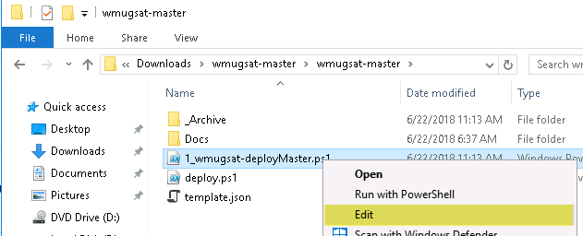
3. Select the following lines and then press F8 to run the selection  
     
   Select “yes” when popup shows up to confirm installing from an untrusted (NuGet) source
4. Enter your tenant name (the one you created when you activated the Azure Pass)  
   
5. Select the following lines and then press F8 to run the selection  
   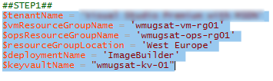
6. Select line “Login-AzureRMAccount” (or just place the cursor on the line) and press F8 to run the selection
7. Login to your Azure Account  
   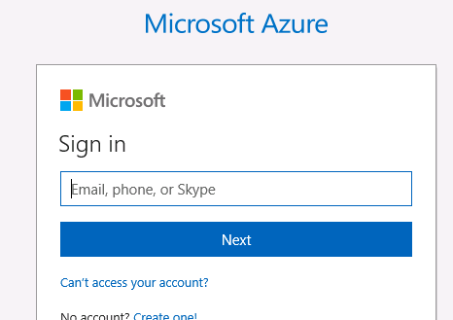
8. Select line “Get-AzureRmSubscription” and press F8 to run the selection  
   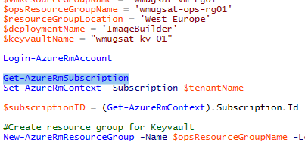
9. Check if you are on the correct subscription before continuing.  
   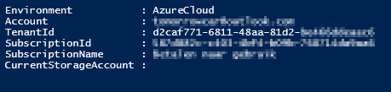
10. Select line “Set-AzureRmContext -SubscriptionName $tenantName” and press F8  
    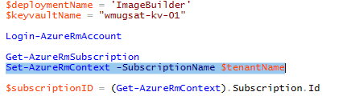  
    *\*\*The Subscription Name was already entered in the previous steps. Make sure the name matches the name shown on screen after you logged on to Azure!*
11. Select line “$subscriptionID = (Get-AzureRmContext).Subscription.Id” and press F8  
    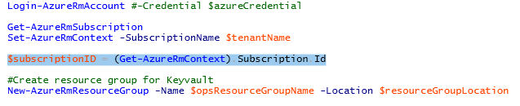  
    *The subscription ID will be used in a later step!*

# Step 2 – Create an Azure Keyvault

## Overview

In this first step we are going to create an Azure Keyvault and add a new secret to the Keyvault. These steps are all performed on the Virsoft lab virtual machine.

## Detailed Steps

1. Login to the Azure portal (on either your own laptop or the Virsoft lab VM) by going to:  
   <http://portal.azure.com>
2. Select “Resource groups”  
   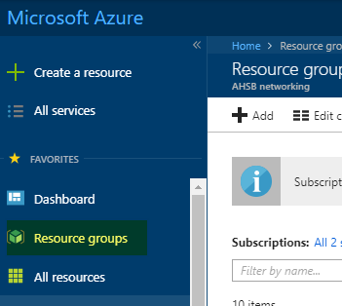
3. Make sure that there is no resource group present with the name: “wmugsat-vm-rg01” or “wmugsat-ops-rg01”
4. Go back to the PowerShell ISE window on the Virsoft lab VM
5. Create a new resource group by selecting line “New-AzureRmResourceGroup -Name $opsResourceGroupName -Location $resourceGroupLocation” and pressing F8  
   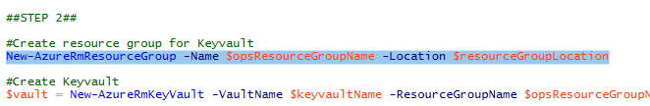
6. Select line “$vault = New-AzureRmKeyVault -VaultName $keyvaultName -ResourceGroupName $opsResourceGroupName -Location $resourceGroupLocation -EnabledForTemplateDeployment” and press F8  
   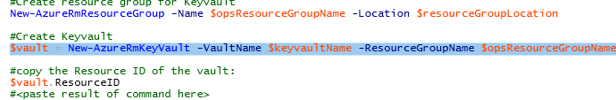
7. Select line the following lines and press F8  
   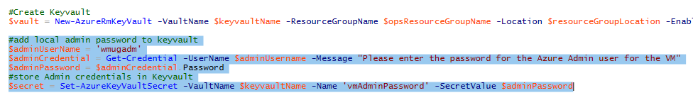
8. Enter a password in the credential window that will appear. Make sure that the password has at least 12 character and has at least 1 uppercase, 1 lowercase and 1 number.  
   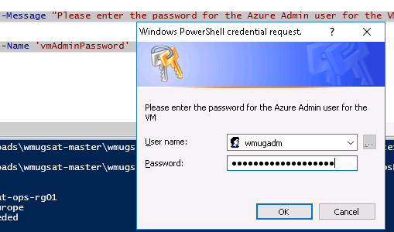
9. Go back to the Azure Portal and refresh the resource groups. A new resource group with then “wmugsat-ops-rg01” will now be present
10. Select that resource group and notice that the created Keyvault “wmugsat-kv-01” is also present
11. Select the Keyvault “wmugsat-kv-01”
12. Select “Secrets” and look for the secret “vmAdminPassword”. It should be present and enabled  
    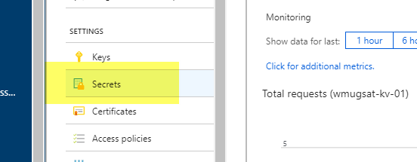

# Step 3 – Use ARM template to create a new Azure VM

## Overview

In this step we are going to use Azure ARM to create a new Azure VM. The ARM template will create an Windows Server 2016 server with an additional 300GB data disk. The process will use the admin password we added earlier in the Keyvault to provision the local admin account “wmugadmin” on the new Windows 2016 VM. This step will take 5-10 minutes.

## Detailed Steps

1. Select the last line and press F8 to run the selection  
   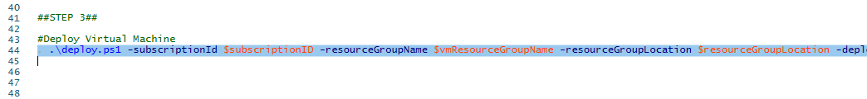
2. This process will take some time. The progress will be displayed (verbose output) in the ISE PowerShell console. Wait until the process has finished before continuing to the next step  
   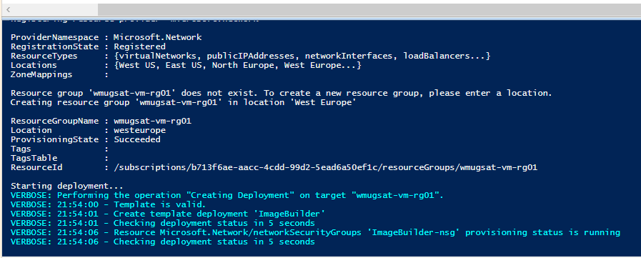
3. Meanwhile you can open script “deploy.ps1” to see the code that is used to deploy the ARM template. The ARM template is also in the repository under the name “template.json”

# Step 4 – Connect to the new Azure VM using RDP

## Overview

In this step we are going to connect to the new Azure Virtual Machine. Perform the next steps on your own laptop (because of a better screen size) or on the Virsoft lab VM.

## Detailed Steps

1. Go to the Azure Portal
2. Select resource group “wmugsat-vm-rg01” (you will need to refresh the resource groups first before you see it)
3. Check is the following resources are present:  
   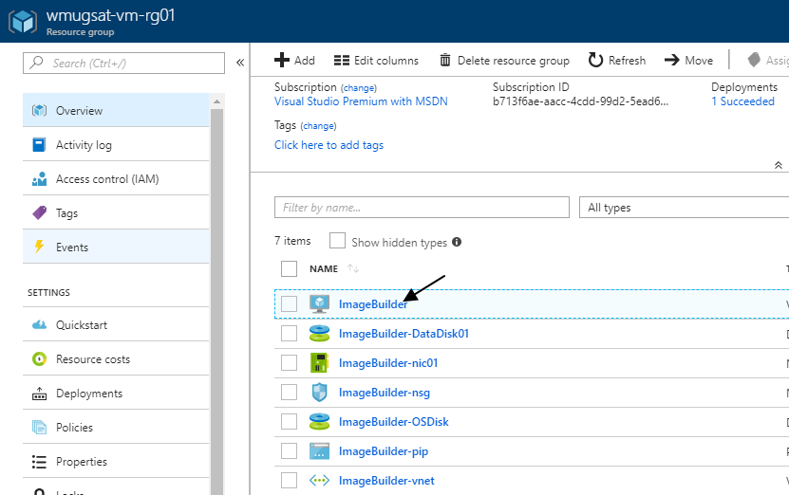
4. Select virtual machine “Imagebuilder”
5. Select the “Connect” button and then select “Download RDP file”  
   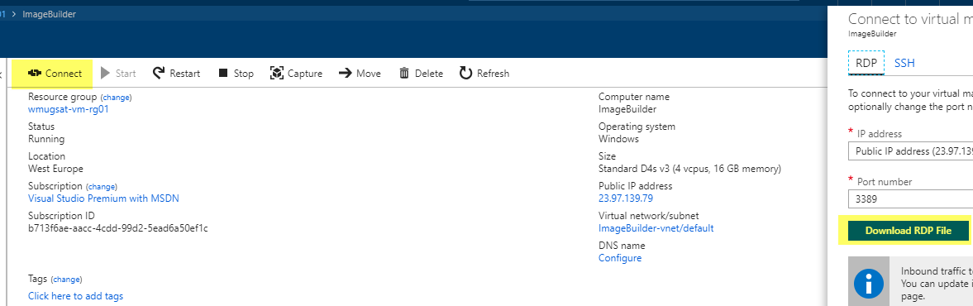
6. Open the downloaded file to connect to the new Azure VM
7. Make sure that you enter “wmugadm” as the account and the use the password you entered during the Keyvault steps.
8. Disable the “IE Enhanced Security Configuration” for both administrators and users in Server Manager – Local Server  
   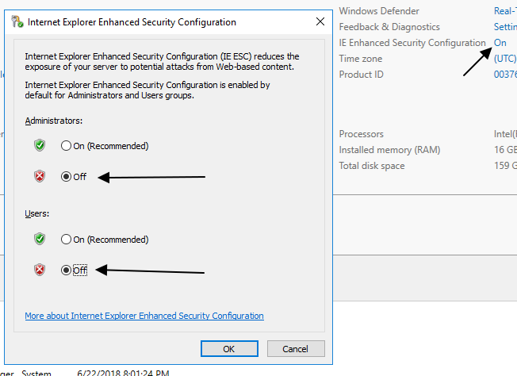

# Step 5 – Prepare Image Builder (Image Factory)

## Overview

In this step we are going to connect to prepare the Image Builder (Image Factory). This step will format the data disk, download software and install required features. All steps must be performed on the Azure VM!

## Detailed Steps

1. Go to: <https://github.com/ArjanBakr/wmugsatImgBuilder>
2. Download the repo by selecting:  
   Clone or Download  
   Download zip  
   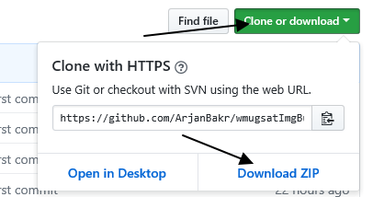
3. Download and save the file to the default location
4. After download open the file location
5. Unzip the file in the default location  
   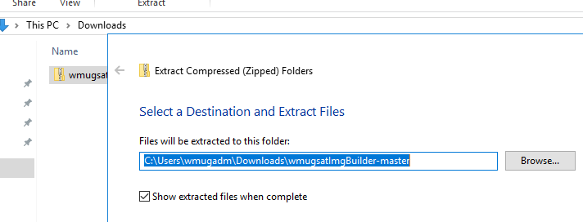
6. Go to folder “C:\Users\wmugadm\Downloads\wmugsatImgBuilder-master\wmugsatImgBuilder-master”
7. Right-click file “1_ImageBuilderSetup.ps1” and select “Edit”
8. Select the following lines and press F8 to run the selection  
   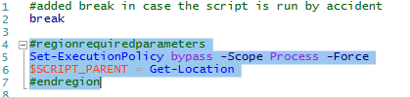
9. Create a hash table by selecting the following lines and pressing F8. The information in the hash table will be used in the rest of the script lines.  
   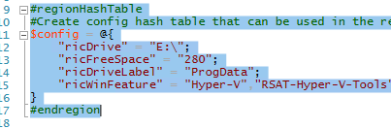
10. Now install the AzureRM module. The module is needed to download (and eventually upload) files from / to Azure Storage. Select the following lines and press F8  
    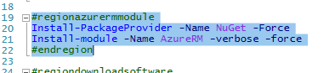
11. We need to download the required software. Select the following lines and press F8 to download al the files needed to perform the next steps.  
    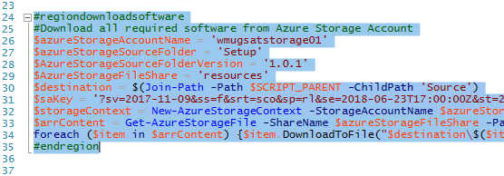
12. Copy some modules to the PowerShell modules folder by selecting the following lines and again….press F8  
    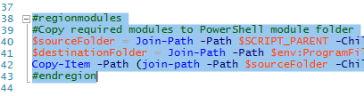
13. Moving the CDROM drive to a different drive letter. Select the following lines and press F8 to do the magic.  
    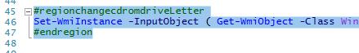
14. The Azure VM has an additional data disk, but we need to initialize and format the disk. Select the following lines and ……well you should by now….press F8  
    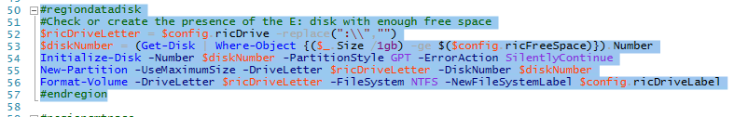
15. Copy CMTrace to the local disk. CMTrace can be used to view log files later on. Select the following lines and press F8  
    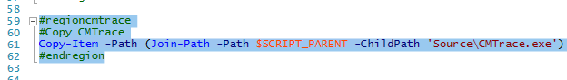
16. Now we need to install all required features needed to run the Image Builder. The list of all required features can be found in the hashtable or the first lines of the script. Select the lines and press F8. This will take some time….hang on!  
    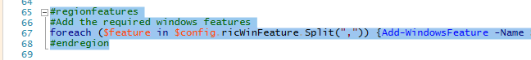
17. Time to restart the server. Select the last lines and press F8 one more time (in this step). The restart will take about 5 minutes.  
    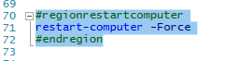

# Step 6 – Install Image Builder (Image Factory)

## Overview

In this step we are going to connect to install the Image Builder (Image Factory). This step will install the minimal required software needed to run the Image Factory script used to create new reference image. All steps must be performed on the Azure VM!

## Detailed Steps

1. Login to the ImageBuilder VM using the RDP file you downloaded earlier
2. Go to folder “C:\Users\wmugadm\Downloads\wmugsatImgBuilder-master\wmugsatImgBuilder-master”
3. Right-click file “2_ImageBuilderSetup.ps1” and select “Edit”
4. You will probably see a message about ISE not being closed properly the last time and the previous script is still open. Close the previous (1_ImageBuilderSetup) script.
5. Select the following lines and press F8 to prep the PowerShell environment  
   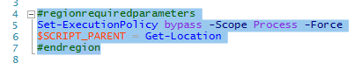
6. Select the entire Hash Table and press F8 to add the information to the table  
   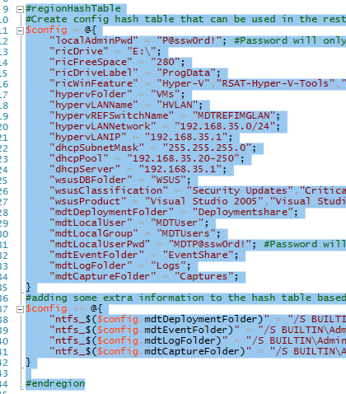
7. We are now going to prepare the Hyper-V server and the Hyper-V switch. The switch will get an fixed IP address. Select the following lines and press F8  
   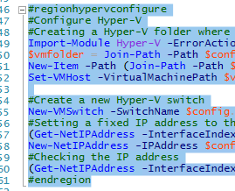
8. Next step is to configure the WSUS server. This step is not running every required action, because syncing the WSUS database will take about 30 minutes, so we are skipping this for now. Normally you need to do this before you can select the products for which updates will be downloaded. Collapse the ‘regionwsusconfigure’ section by clicking the – symbol. Then select the line and press F8. This will run the entire code in that region  
     
   This step will take about 5 minutes to complete!
9. If the process failed, please run the region ‘regionwsusconfigure’ again!
10. Next step is to add additional software like SQL CLR Types, SQL Reportviewer, ADK, MDT, StarwindConverter software, etc. Select each block in the region ‘regionadditionalsoftware’ and run the selected block by pressing F8. ***Do not run the entire region at once….It was not tested in this lab!***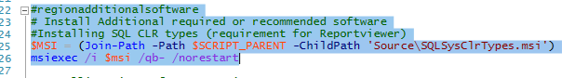
11. Repeat this step for each software block in this region
12. The Windows Assessment and Deployment Kit will show the GUI and you will need to select **Next, Next, Accept, Install**. This was intended!  
    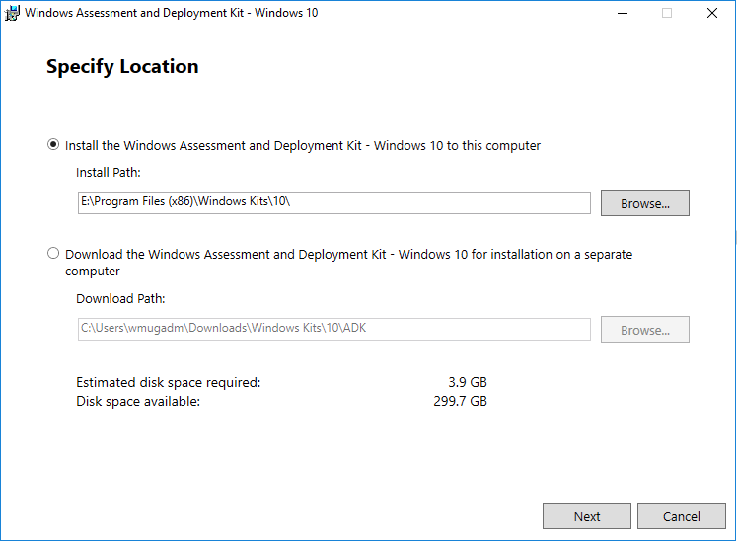  
    The installation will take some time to complete
13. Next we will need a local account and a local group. The account and group are used the connect to the MDT shares from a running virtual machine. Select the following lines (or collapse the region and select that region). Press F8 to create the account and group.  
    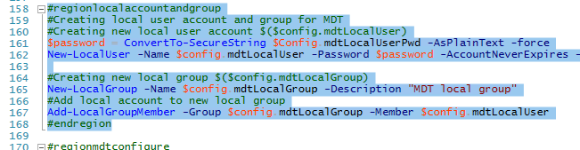
14. Almost there…..To configure the MDT settings, we will need to run the following region. This will create folders, shares and set NTFS rights. It will also prepare MDT for the first use and create the bootstrap.ini and customsettings.ini files. These files are required and will make MDT work together with the Image Factory script. Select or collapse the line in the region ‘regionmdtconfigure’ and press F8 to run the code
15. Close PowerShell ISE (important step!)

# Step 6 – Configure Image Builder (Image Factory)

## Overview

In this step we are going to configure the Image Builder (Image Factory). This step will copy configuration to the MDT folder. The configuration will first be downloaded from a storage account. Once copied the MDT environment is ready to go. All steps must be performed on the Azure VM!

## Detailed Steps

1. Go to folder “C:\Users\wmugadm\Downloads\wmugsatImgBuilder-master\wmugsatImgBuilder-master”
2. Right-click file “3_ImageBuilderConfig.ps1” and select “Edit”
3. Select the following lines to configure the PowerShell environment. Off course you have to press F8 again  
   
4. Define the Hash Table again by selecting the following lines of code (or collapse the region and then run that region)  
   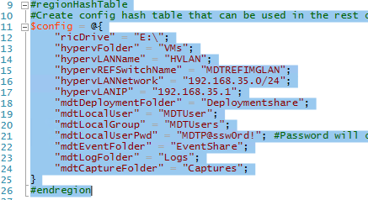
5. The next lines of code will install SQL command line utilities and ODBC drivers. It will then copy a WSUS maintenance script (the last one you will ever need) and create a scheduled task to maintain the WSUS database. Select the following lines and……well you know by now….will you make me say it again?…..(sigh) Press F8!  
   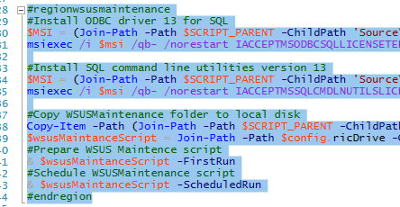
6. Download the configuration by running the next region of code (regiondownloadsoftware)  
     
   Depending on the number of participants in this lab, this download process will take some time (approx. 10 minutes)  
   Configuration files and folder are copied to: E:\DeploymentShare\Applications, E:\DeploymentShare\Control and E:\DeploymentShare\Operating Systems. This config is an example configuration for creating a **Windows 2016 Standard Core** reference image.
7. Run the following lines to download all Visual C++ runtime version to the Applications\InstallVCRuntime 1.00 folder. These installers will be used during the reference image creation process  
   
8. The final step in this configuration section is to create the MDT boot image. Select the following lines to create the ISO file. The ISO will be connected to the Virtual Machines. The ISO is needed to connect to the MDT server and runt the required task sequence.  
   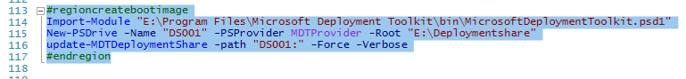

# Step 7 – Use the Image Factory script to create a reference image

## Overview

In this step we are going to use the Image Factory script to create a new reference image. We will also take a look at the working parts of this Image Builder server. All steps must be performed on the Azure VM!

## Detailed Steps

1. Open the MDT workbench application in the start menu  
   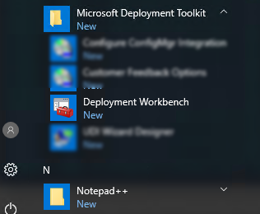
2. Check if the following applications are present in MDT:  
   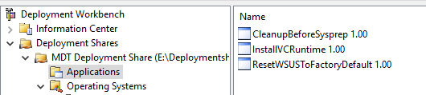
3. Check if the following Task Sequence are present in MDT:  
   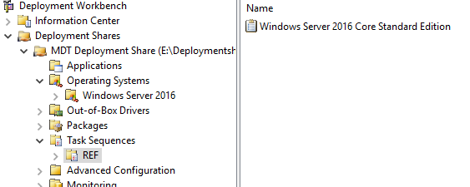
4. Check if the following Operating System are present in MDT:  
   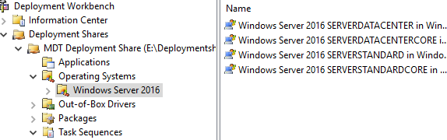
5. Open a new PowerShell session
6. Go to: E:\ImageCreator
7. Go to subfolder “DHCPServer” and start **dhcpsrv.exe**
8. Select **Configure** to create the required firewall rules (the rules in the script are not working unfortunately)  
   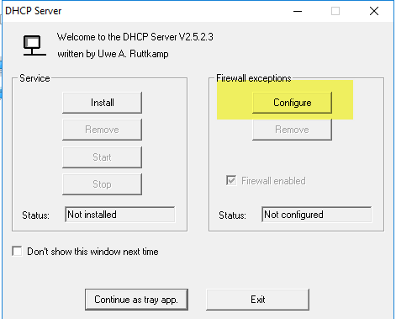
9. Exit the application
10. The DHCP server application will be used to offer IP addresses to the running Virtual Machines on the Hyper-V switch (LAN)
11. Run the following command to create a new reference image:  
    .\ImageFactoryV3-Build.ps1  
    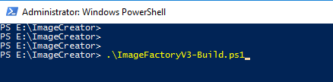
12. The process will start. You can open Hyper-V manager and see that a new virtual machine is created and the VM is installing Windows 2016 Core Edition. It will also install all Visual C++ runtimes, .Net 3.5 and .Net 4.7. It will check for Windows Updates (but won’t find any because we did not sync the WSUS catalog) and clean up the image before running sysprep.
13. The last step is to create a WIM file. The captured file can be found in the following folder:  
    E:\DeploymentShare\Captures
14. Logging of the entire session can be found at:  
    E:\DeploymentShare\Logs